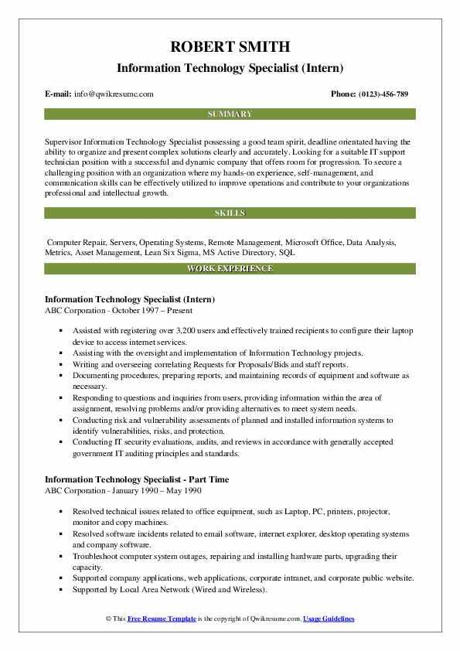
ROBERT SMITH
Information Technology Specialist (Intern)
E-mail: info@qwikresume.com
SUMMARY
Phone: (0123)-456-789
Supervisor Information Technology Specialist possessing a good team spirit, deadline orientated having the ability to organize and present complex solutions clearly and accurately. Looking for a suitable IT support technician position with a successful and dynamic company that offers room for progression. To secure a challenging position with an organization where my hands-on experience, self-management, and communication skills can be effectively utilized to improve operations and contribute to your organizations professional and intellectual growth.
SKILLS
Computer Repair, Servers, Operating Systems, Remote Management, Microsoft Office, Data Analysis, Metrics, Asset Management, Lean Six Sigma, MS Active Directory, SQL
WORK EXPERIENCE
Information Technology Specialist (Intern)
ABC Corporation-October 1997 - Present
⚫ Assisted with registering over 3,200 users and effectively trained recipients to configure their laptop device to access intemet services.
• Assisting with the oversight and implementation of Information Technology projects.
⚫ Writing and overseeing correlating Requests for Proposals/Bids and staff reports.
■ Documenting procedures, preparing reports, and maintaining records of equipment and software as necessary.
• Responding to questions and inquiries from users, providing information within the area of assignment, resolving problems and/or providing alternatives to meet system needs.
• Conducting risk and vulnerability assessments of planned and installed information systems to identify vulnerabilities, risks, and protection.
• Conducting IT security evaluations, audits, and reviews in accordance with generally accepted government IT auditing principles and standards.
Information Technology Specialist - Part Time
ABC Corporation - January 1990-May 1990
⚫ Resolved technical issues related to office equipment, such as Laptop, PC, printers, projector, monitor and copy machines.
⚫ Resolved software incidents related to email software, internet explorer, desktop operating systems and company software,
⚫ Troubleshoot computer system outages, repairing and installing hardware parts, upgrading their capacity.
• Supported company applications, web applications, corporate intranet, and corporate public website. Supported by Local Area Network (Wired and Wireless).
This Free Resume Template is the copyright of Qwikresume.com, Usage Guidelines

